December 24, 1915
Worship of Others Besides Allah and the Straightforward Islamic Path to Resolve Religious Differences
I bear witness that none deserves to be served besides Allah and I bear witness that Muhammad is the servant and messenger of Allah. —
After this, I seek the protection of Allah from the accursed devil.
In the name of Allah, the Beneficent, the Merciful.
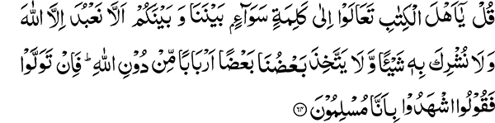
“Say: O People of the Book, come to an equitable word between us and you, that we shall serve none but Allah and that we shall not associate aught with Him, and that some of us shall not take others for lords besides Allah. But if they turn away, then say: Bear witness, we are Muslims.” (3:64)
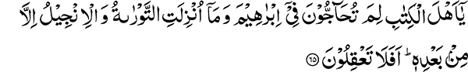
“O People of the Book, why do you dispute about Abraham, when the Torah and the Gospel were not revealed till after him? Do you not understand?” (3:65)
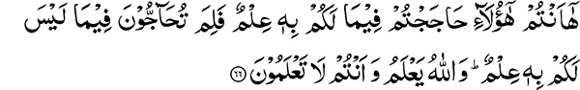
“Behold! You are they who disputed about that of which you had knowledge; why then do you dispute about that of which you have no knowledge? And Allah knows while you know not.” (3:66)
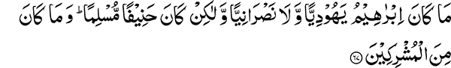
“Abraham was not a Jew nor a Christian, but he was (an) upright (man), a Muslim; and he was not one of the polytheists.” (3:67)
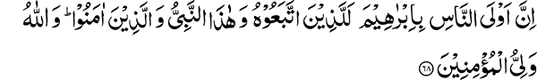
“The nearest of people to Abraham are surely those who follow him and this Prophet and those who believe. And Allah is the Friend of the believers.” (3:68)
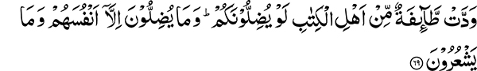
“A party of the People of the Book desire that they should lead you astray; and they lead not astray but themselves, and they perceive not.” (3:69)
“O People of the Book, why do you disbelieve in the messages of Allah while you witness (their truth)?” (3:70)
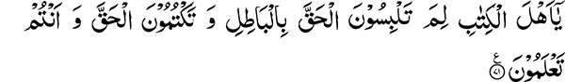
“O People of the Book, why do you confound the truth with falsehood, and hide the truth while you know?” (3:71)
The Extent of Polytheism During the Holy Prophet’s time and his Compassion to Deliver Humanity from it
These verses of the Holy Quran reflect the great compassion the Holy Prophet had for people to accept and stand firm upon the principle of Unity of the Divine Being. It also becomes apparent that in fact all the effort the Holy Quran has put into refuting the various offshoots of polytheism was not the result of the Holy Prophet’s own desires. Before him was a society steeped in various forms of idol worship. The sun, trees, stones, sticks and straws, air, water, and fire were all worshipped and this was the prevalent form of polytheism. This form of association with God has, however, not received as much attention in the Holy Quran as that which is referred to in the words “and that some of us shall not take others for lords besides Allah.” This type of association with Allah has been refuted in the Holy Quran with strong arguments well illustrated by the debate with the Christian delegation of Najran. Ultimately, when these arguments failed to convince them, the Holy Prophet invited them to pray earnestly that the curse of Allah might overtake the party that insisted on falsehood. It seems that the Holy Prophet was given this knowledge. In fact, the great damage caused by this form of association and the extent of its spread in the future on a much wider scale than the prevalent form of polytheism was in the knowledge of Allah the Most High. The Holy Quran describes it in these words:
“The heavens may almost be rent thereat, and the earth cleave asunder, and the mountains fall down in pieces, that they ascribe a son to the Beneficent!” (19:90-91)
The magnificence of these words and the awe they inspire indicate that those who “ascribe a son to the Beneficent,” will become predominant to such a degree that they will be the cause of destruction of God’s creation. Observe that although the Holy Prophet spent thirteen years in Makkah condemning all forms of idol worship with cogent arguments, he was never commanded to extend this challenge:
“Whoever then disputes with thee in this matter after the knowledge that has come to thee, say: Come! Let us call our sons and your sons and our women and your women and our people and your people, then let us be earnest in prayer, and invoke the curse of Allah on the liars.” (3:61)
This was because the form of polytheism prevalent in Arabia was soon to disappear.
Invitation for a Deprecatory Prayer Duel (Mubahalah) for the Worst Form of Polytheism
This decisive challenge was presented to the Christian delegation of Najran visiting Madinah only after presenting them with incontrovertible proofs regarding falsity of their beliefs. The birth of Jesus, his childhood, youth, and eventual death were all mentioned by the Holy Prophet in his discussion with the Najran delegation in order to prove that he did not possess any attributes that made him divine. Having undergone all the physical changes humans go through, he could certainly not have been God. After presenting all these arguments, when it was realized that they were unwilling to accept the truth, the Holy Prophet was commanded to tell them:
“Whoever then disputes with thee in this matter after the knowledge that has come to thee, say: Come! Let us call our sons and your sons and our women and your women and our people and your people, then let us be earnest in prayer, and invoke the curse of Allah on the liars.” (3:61)
The Result of the Deprecatory Prayer Duel (Mubahalah)
This was the battlefield for a spiritual altercation or contest. Had they consented to it, they would have been wiped out by visitation of a heavenly calamity. They chose to abstain and were given a pledge whereby they were free to practice their religion. Their co-religionists however, had to bear the consequences in a physical sense later on in history when they waged aggressive warfare against Muslims and were utterly defeated. They participated in the crusades with great zeal and fervor and even their women and sons accompanied them. It is narrated that a twelve-year-old instigated other youngsters with his preaching and a whole army of boys joined him. When they worried about how they would cross the sea, they were told to hit the wooden staff they had in their possession against the sea shore and the sea would part for them. In short, they abstained from the spiritual encounter to which they were invited. Instead, they chose to do battle with Muslims to deprive them of the land that was spoken of as a sign of truth in the prophetic words of the Holy Quran:
“And certainly We wrote in the Book after the reminder that My righteous servants will inherit the land.” (21:105)
The combined forces of the European crusaders were met single-handedly and defeated by Salah-ud-din Ayubi. This happened because they made an attempt to destroy a sign of truth and capture the Holy Land in order to prove that they were more capable. The spiritual challenge in the form of the deprecatory prayer duel (mubahalah) was put forth by Allah the Most High to demonstrate that if they had accepted it, they would have been vanquished in a spiritual sense also.
Another Means of Reaching a Decision
Another way of coming to a decision is now pointed out. The Holy Quran states:
“Say: O People of the Book, come to an equitable word between us and you.”
This equitable word is that you search your Holy Scriptures and we search ours and agree upon what we find in common. There could still be some matters of difference, but we could still accept and follow those we have agreed upon.
It seems that this was the last weapon with which falsehood was destroyed. If we study the history of comparative religion, it becomes clear that this is a simple way of reaching a decision that Islam has shown. This is indeed an excellent method. By following this, one can immediately conclude that Islam is in principle the only truthful religion. Today, Europe has recognized that the principles of Islam are based upon truth. I have observed that when we take all the religions of the world, sort out the common ground, and establish it as a core principle, what remains behind are the contentious and peripheral issues. If these are set aside, it is proven with certainty that the Islamic principle of Unity of the Divine Being is the correct one. This is how I have studied religions. If you look at this very example, you will find it in The Torah. And Jesus also says, “The Lord our God is one Lord” (Mark 12:28-34).
Unity of the Divine Being in Principle and not in Practice
People, however accepted the Unity of the Divine Being in principle but not in practice. Jews, for example, pointed out this verse of the Holy Quran: “They take their doctors of law and their monks for lords besides Allah,” (9:31) and asked the Holy Prophet how this applies to them. The Holy Prophet replied, “Do you not accept what your rabbis and doctors of law call lawful (halal) as lawful and what they call unlawful (haram) as unlawful?” They replied in the affirmative. This, he said, is proof for taking lords besides Allah.
God created you as human beings and gave you intellect and discretion but you do not use your intelligence. After all, who are your doctors of law and monks? They are human beings just like you. They use their intellect while you do not. God has created man to use his intellect and discretion.
Islam Put the Principle of Unity of the Divine Being into Practice
The doctors of law and monks of the Jews were the same as your spiritual mentors (pirs), and who are they? They were humans like you and me who perhaps read a few more books and on this basis claim spiritual leadership. You fail to use your intellectual faculties in this direction nor do you deliberate or ponder, but instead you choose to follow them blindly and what they say becomes law. It should not have been so. Amongst you, should be those who are prepared to correct them when they follow the wrong path. Where can we find people who have the moral fabric of the Holy Prophet’s companions? A woman of Madinah stands up and corrects a person of Hazrat Umar’s standing by challenging his stance regarding the marriage dowry and quotes this verse of the Holy Quran: “And you have given one of them a heap of gold, take nothing from it” (4:20). This was the level of their understanding and following of the Holy Quran. When the condition of the nation becomes such that they no longer have knowledge of Islamic law, those who possess a little knowledge become their spiritual mentors and people follow them blindly. A nation can advance only when upon seeing someone act contrary to the teachings of the Holy Quran, every individual amongst them is ready to forcefully condemn and correct his actions.
Seek Knowledge of the Holy Quran and Hadith and Act with Prudence
Your condition should be such that you know what the Holy Quran says and you are aware of what the teachings of the Holy Prophet are. Dedicate an hour, or at least some time during the day, to study the Holy Quran. Study the Hadith and have the acumen and knowledge to grasp mistakes others are making in this matter. The problem is you have stopped deliberating. People are busy in other worldly tasks and do not reflect upon the Holy Quran. If you ask them about having a Quran in their possession, they will have many and perhaps some very expensive volumes, but they are unaware of what is written in them.
By extending the invitation in these words: “Come to an equitable word between us and you,” Islam has settled all the contentious issues. This statement is living proof of the truth of Islam. There are people who raise objections against Hadith and consider them to be incorrect. Some go to the extent of using abusive language against Imam Bukhari (may Allah be pleased with him). The other day, a certain individual said, right in front of me, that Imam Bukhari has just collected a pile of useless paper. In fact, just this verse of the Holy Quran answers all their objections. It is part of the letter written by the Holy Prophet Muhammad to Heraclius, Emperor of Rome, copies of which exist in the books of Hadith. The original letter has now been discovered and each letter of it exactly matches the text in the Hadith, which has the Holy Prophet’s stamp on it.
Abraham was a Believer in the Absolute Unity of the Divine Being
“O People of the Book, why do you dispute about Abraham?” Abraham stands for the equitable word amongst nations of the world. The people of the Book are invited to the equitable word, the worship of one God, the common ground between us and them. Abraham is accepted as the revered patriarch and prophet amongst Muslims, Jews, and Christians. It is now demonstrated practically what the equitable word is. It is the religion of Abraham. Abraham was not a follower of the teachings of the Torah or the Gospel for, “The Torah and the Gospel were not revealed till after him.” Even today Christians say that Prophet Abraham and Moses believed in the vicarious sacrifice. The Holy Quran points out that both the Torah and the Gospel were revealed after Abraham and then asks the logical question, “Do you not understand?”
“Behold! You are they who disputed about that of which you had knowledge; why then do you dispute about that of which you have no knowledge? And Allah knows while you know not.” (3:66)
“Abraham was not a Jew nor a Christian, but he was (an) upright (hanif) (man), a Muslim; and he was not one of the polytheists.” (3:67)
The word upright (hanif) refers to one who avoids the path of excess or deficiency and follows the course of moderation.
The Holy Prophet and Muslims Follow the Religion of Abraham
What is the religion of Abraham? The Holy Quran now tells us: “The nearest of people to Abraham are surely those who follow him and this Prophet and those who believe. And Allah is the Friend of the believers.” (3:68)
Following the religion of Abraham, which is shirking all forms of polytheism, brings us closest to him.
There was a manifest sign related to Prophet Abraham and that was the promise made with him by Allah the Most High. “And I will give unto thee, and thy seed after thee, the land wherein thou art a stranger, all the land of Canaan, for an everlasting possession; and I will be their God” (Gen. 17:8). Remember that this promise is to be fulfilled by those who are in outward possession of this Holy land, otherwise Jews and Christians will have to accept that their books are in error regarding this matter. As long as the People of the Book followed the religion of Abraham and fulfilled the covenants they made with Allah the Most High, they remained in possession of the land of Canaan and were the nearest of people to Abraham. Now that they have discarded the religion of Abraham, the true verifiers and proof of this covenant are, “this Prophet and those who believe” and this land will remain in their possession. The words, “and those who believe,” clearly show that the true owners will be those who believe in the Holy Prophet. The chain of physical sons remains no longer, for it was terminated with the children of Israel and now only the spiritual inheritance remains. This is the truth that is fully exposed in the verse: “Muhammad is not the father of any of your men, but he is the Messenger of Allah and the Seal of the prophets. And Allah is ever Knower of all things” (33:40).

A mubahalah invokes Divine decisions through prayer after argumentation has failed. Both parties pray to God that whichever of them intentionally rejects the truth may be visited with heavenly calamity to serve as a warning to others.
Canaan was a Semitic-speaking region in the Ancient Near East, roughly corresponding to the Levant, i.e. modern-day Lebanon, Israel, Palestinian territories, the western part of Jordan and southwestern Syria.

